BACKEND DEVELOPMENT ASSINGMENT TWO
1a) I would be working with opay as my banking app. when I tap log in button on my opay app, the frontend what I see and interact with on my screen collects my login details that is my pin, then it sends this information as a log in request to the backend which process the requests. The backend communicates with the data base (where all my information is kept) to retrieve my information needed to verify the log in details. The backend determines whether the login should be accepted and gives a response to the frontend which then allows you to log in to your home screen. Same also applies when you want to make a transfer, purchase a product online and also log into other apps.

1b) I would be using a restaurant as my analogy. In a restaurant we have the menu(frontend), the kitchen where food is been prepared (backend) and where records containing the restaurant menu, prices and customers’ orders. (The data base). When a customer enters a restaurant, he/she take a look at the menu to see the food and their prices. This is the frontend part because this is what the customer interacts with. After the customer places his or her order, the kitchen receives this order/handles the customer request after checking the restaurant record to confirm the available meal and their prices. Note that this analogy is not exactly same as a real backend because the restaurant kitchen prepares physical food, while a software backend processes digital requests and data.

2a. Node js is not a programming language because a programming language is a language programmers use to give instructions to computers.eg (java script), node js doesn’t do that because it’s a runtime environment for JavaScript it allows, java script run on your computer, it allows java script to be executed outside the browser. Talking about the runtime, a runtime is the environment which the program executes on/works on. This node js is built on google v8 engine, which is responsible for executing JavaScript code.it helps convert JavaScript code into machine code that the computer can run.
2b. Before node js, JavaScript was mainly used in web browsers to make website interactive. IN 2009 a programmer Ryan dahl introduced node js that could allow developers run JavaScript outside the browser, by taking node js outside the browser developers where able to use JavaScript on the server side to build web servers and backend appilcations.Node.js then allowed JavaScript to handle multiple input and output tasks without having to block the main thread while waiting for them to finish.

3a. Using a restaurant as a real-life scenario to explain how the event loop, event queue, thread pool and call back: Assuming a waiter working in a busy restaurant is taking different orders from several customers. The waiter cannot serve all these customers at once so it takes the first order and gives it to the kitchen to prepare, instead of waiting for the chef to finish preparing customer 1 meal, the waiter moves to another table to take its other and many more while the chef keeps preparing the first customers meal. This shows how one worker can coordinate multiple tasks at once without waiting for one task to finish first before moving to the next. The kitchen workers represent the thread pool which handles the tasks in the background, the event loop helps to coordinate the processing of this tasks when they are ready (it coordinates the waiter activities, allowing him to attend to other customers instead of waiting for every meal to be ready, the event queue is just like a waiting line for tasks that are waiting to be processed. When the chef finishes preparing customer one meal, a call back just like a reminder that this person request has been completed the waiter can the respond to the call back and serve the customers meal.
3b. A scenario where this approach would fail badly would be a bank. Imagine a bank where one staff member attends to several customers. When customers come to withdraw money, they normally wait in in a queue until it’s their turn eventfully a customer may bring a very complicated transaction that requires careful inspection, the staff then spends a long time calculating and checking everything carefully before completing it. during this time the other customers would have to wait because because the staff member cannot attend to them. Similarly in node js server, if one request is too heavy and, also involves complicated and long running tasks that blocks the main thread, other requests would be delayed until that task finishes. This can make the server slow, to prevent these developers can allow worker threads to handle heavy tasks separately, allowing the main thread to continue attending to other tasks without delay.

4. document. getElementById(“name”) gives an error in Node.js because document is provided by the browser to access html elements.Node.js runs java script outside the, browser so it does not provide the document object by default. The global object in Node.js is called global.it uses global instead of the browser’s window object.
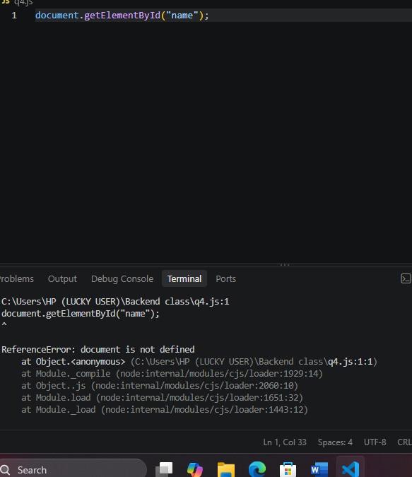

5. It is dangerous to rely on only client-side validation because someone can use a tool or write a script to send data directly to the server without using the signup form, (the could send a pin with 3 characters even though the form requires at least 8. therefore backend must validate the data before accepting it.A person with technical knowledge can send a request directly to the backend without using the form if the backend did not confirm your previous pin.
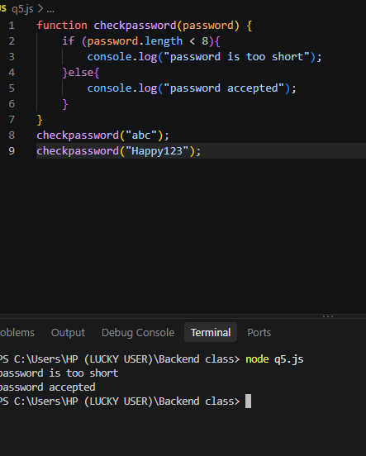
6. The problem is the values where not properly assigned they aren’t assigned correctly and in java script we have to have properly assigned values to each variable to make it work. Some variable names are invalid in java script and const was reassigned a new value.in the previous code a variable was declared twice using let which is wrong. Cost cannot be reassigned a new value after it has been declared using const. here is my worked-out version of the code:
Let age=25;
Let myName = “Tunde”
Const score = 10
Let second place=Ife”
Const pi =3.14;
Let userAge =31
6b. I would chose const when I do not want to assign a new value to the variables after declaring it ,I use let when I know that the variables value may need to be changed later. Many developers start with const because it prevents reassignment and makes the code easier to understand. They are forced to change to let when the discover they value needs to be changed. We avoid using var because it has older and more scoping rules that can cause confusion. It’s different from let and const which makes it more confusing and let and const easier to use.

7. Where I ran my code, the first line worked because we changed the students score from 50 to 90.even though const was use JavaScript allowed us to changed the score because we are changing a property inside the object. The second part worked because grades. Push means we should add four to the array. The last line didn’t work because I was trying to completely replace the entire student object with a new one containing the name bola and age70.since student was already declared using const, java script does not allow us to assign a completely new object to it. Note that the first change was allowed because we were changing a property inside the object not changing the object totally.
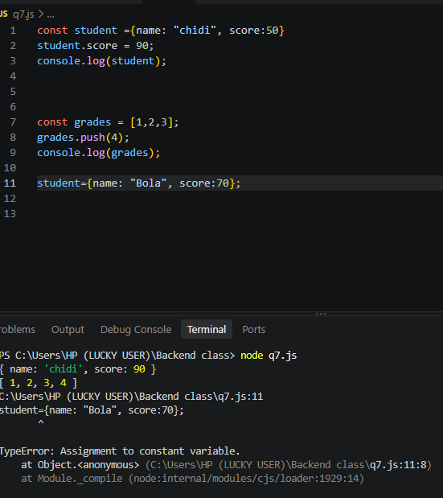

7b. I used object. Freeze () to prevent the student object from changing. When I tried to change score from 50 to 90, the score remines 50 because the object was frozen. In a normal mode, java script silently ignores the attempted change instead of showing an error.
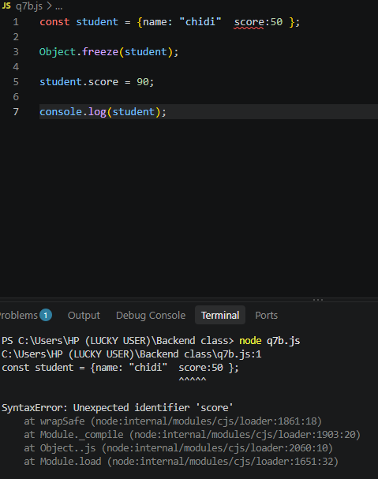

8. My predication console.log (a, b) would be (10,20), because a stores the values of 10 ,and b was assigned to a but b = 20 ,so we only change b to 20,the value of a still remains 10.
My predication for console.log users age would be 40. Because user one age refers to an object with name Amaka and age 22, user two is then assigned to user one making it refer to same object, user two age is 40 which changes the age inside the object.

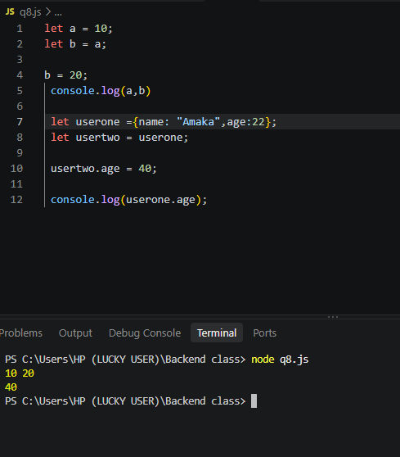

8a. Block one behaves differently from block two because primitive values are copied by the values, while objects are copied by reference. In block one when that statement b=a runs, the value of a is copied into therefore changing b doesn’t affect a. in block two, user one makes variables refer to the same object. therefore, when age is changed through user two, the change is also visible through user one.
8b. Fixing the second code block so changing user two does not affect user one we would use the spread operator (…) to create a shallow copy of user one and assign it to user two. This allows me to change the age user two without affecting user one .so userone.age remains 22 while usertwo.age becomes 40.
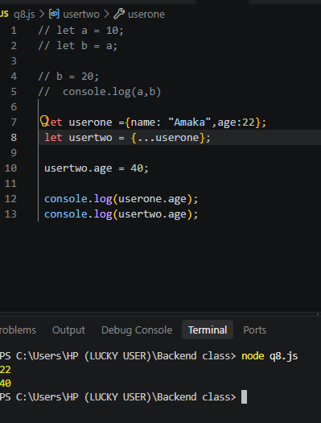
When the object contains another object example address property, the inner object is still shared between the original and copied objects.so changing the inner object through one variable can affect the other.to prevent this we can use the spread operator to copy the inner object separately.

9a 42 would give number
“42” would give “string”
True would give Boolean
Null would give object
Undefined would give undefined
[1,2,3] would give object
{a;1} would give object
Function () {} would give function
NaN would give number

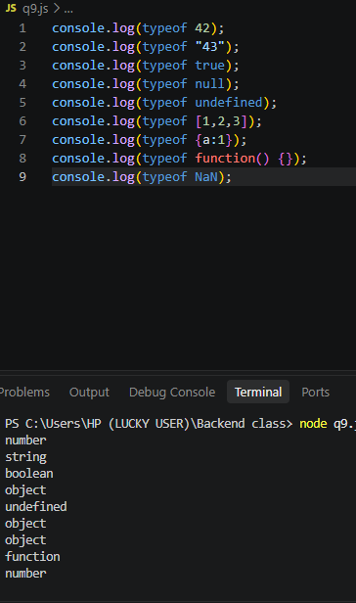

9b. The two surprising results are type of null, which returns “object”, and type of [1,2,3] which also returns “object”. These can cause real problem for a backend cause a developer might mistake null or an array for an object. This can lead to incorrect validation or errors when accessing properties.
9c.

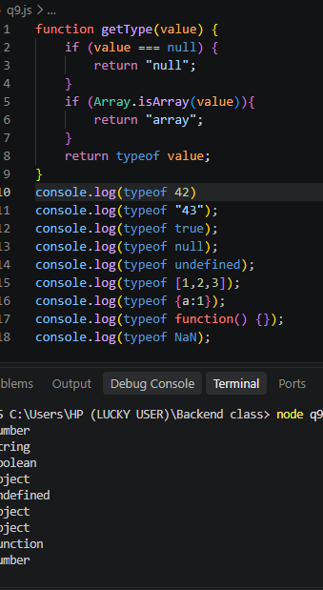

10a

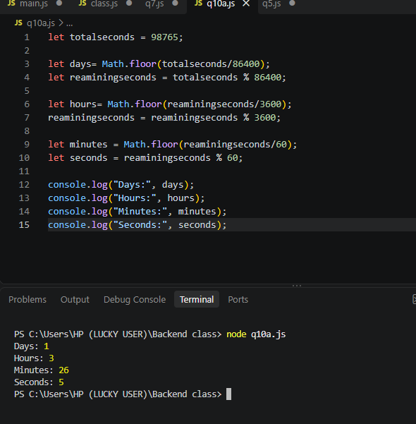

10b.

